**OTT Overview**

**OTT is "over-the-top"** and refers to the delivery of film and television content via the internet without the need for a traditional cable or satellite TV subscription.

Examples of OTT services include **Netflix, Hulu, and Amazon Prime Video**.

Offer users access to a vast library of movies and TV shows on-demand. These services are typically accessed through a web browser or a smart TV app.

The use of a dedicated streaming device, such as a Roku or an Amazon Fire TV.

**OTT ERA**

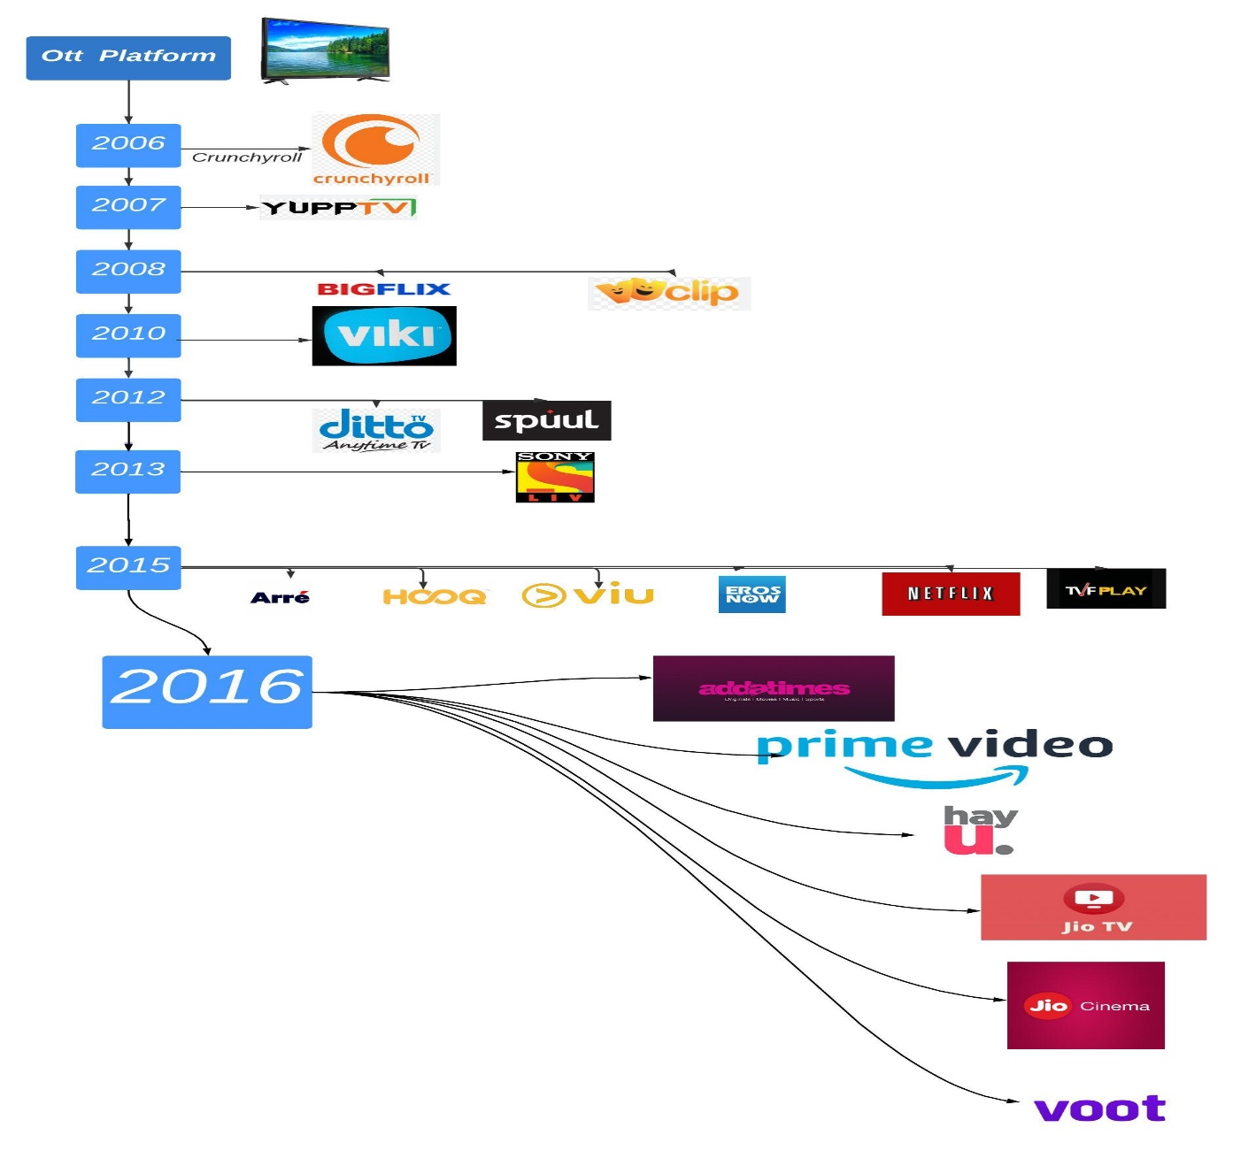

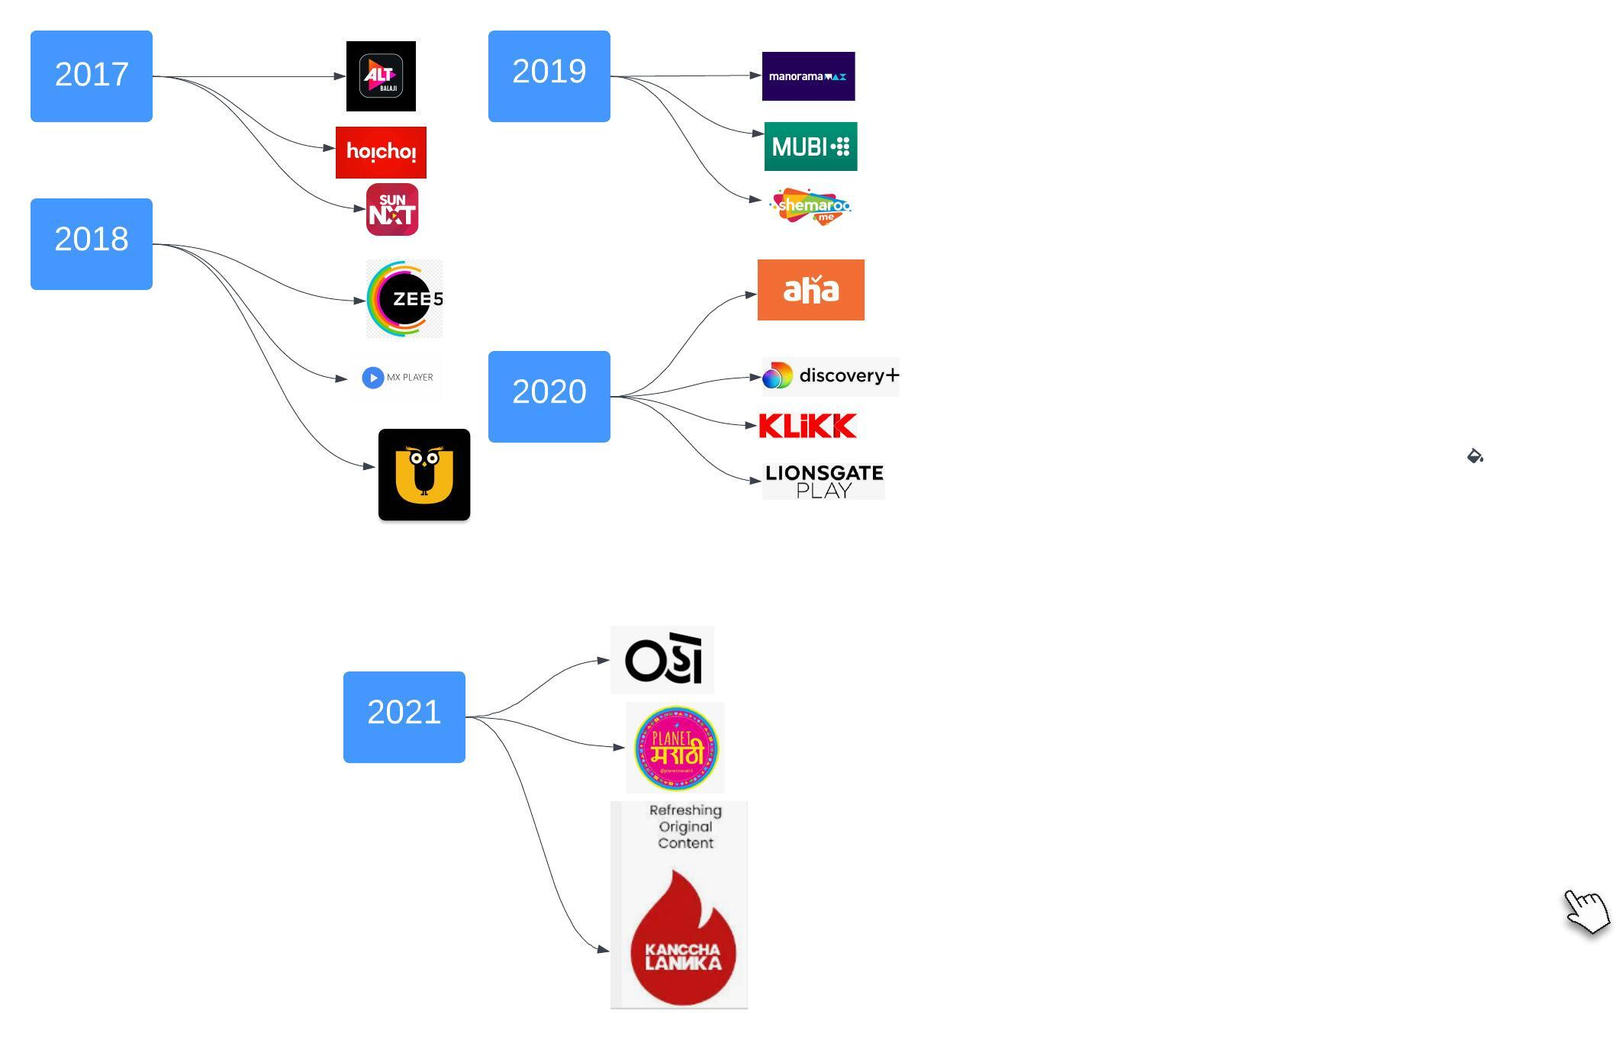

India has a large and rapidly growing internet user base, making the OTT market one of the fastest-growing in the world. It was predicted that by 2023 the Indian OTT market would reach ₹12,000 crore, according to a report by KPMG.

# Emerging OTT Model in the media world

The four major OTT media models are as follows:

1. AVOD
2. TVOD
3. SVOD
4. Hybrid: SVOD + TVOD

## AVOD

The term **AVOD** stands for **Advertising Video-on-Demand**. Advertisers are not charged for watching content through AVOD. However, creators are still charged for selling advertising space. As with traditional TV, you tune in to watch your favorite shows and accept there will be ads to cover production and distribution costs.

**AVOD Pros**

* It’s easy to attract and hook new viewers because there’s nothing to pay.

**AVOD Cons**

* The interruption of the content flow by ads could ruin the user experience and turn viewers away.
* In contrast to creating and selling products, it's a risky way to make money from videos.
* Without a large audience, generating as much revenue as other business models aren’t easy.
* The paradox is that you must serve enough ads to generate revenue without driving viewers away.

Example:

YouTube is the most popular and successful AVOD platform for video creators, where ads appear as:

* Ads that play before the main content are called **Pre-roll ads**.
* Ads that pause the video content at strategic points are called **Mid-roll ads**.
* Ads that appear on the screen during the video are called **In-Video Ads**

These ad types are probably familiar to you:

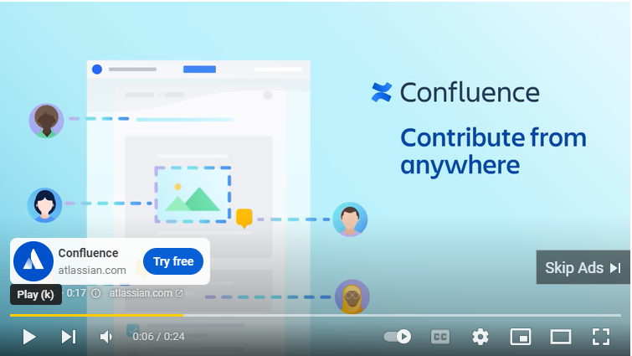

YouTube creators monetize their videos primarily through video ads.

Here 97.5% of YouTubers struggle to earn a living above the poverty line. YouTube accounts for nearly half of a creator’s ad income. For YouTube’s AdSense (advertising) program, you must have more than 1000 subscribers and 5000 valid watch hours in the past year. YouTube can demonetize your channel or videos instantly and randomly.

|  |
| --- |
| Note: A large viewership is necessary for the AVOD model to succeed. Although the content is free ads interrupt people's favorite videos. |

## TVOD

The term **TVOD** stands for **Transactional Video-On-Demand**. TVOD is where customers make one-time purchases to access specific premium content. In some cases, it is referred to as PPV (pay-per-view) or PPD (pay-per-download) since viewers pay only for the videos they want to watch.

For instance, you can watch major televised sports events on Sky Box Office, like boxing matches.

**TVOD Pros:**

* TVOD is perfect if you're only looking to sell or rent one video or a group of videos.
* You can monetize your community on a one-off basis if you have an engaged community.

**TVOD Cons:**

* Since viewers come and go for each video, it isn't easy to build relationships with them.
* To generate consistent revenue, TVOD needs a steady stream of purchases, which means you need to convince both new and old customers to purchase your service.

Example:

TVOD is available on iTunes, Amazon Prime Video, and Sky Box Office.

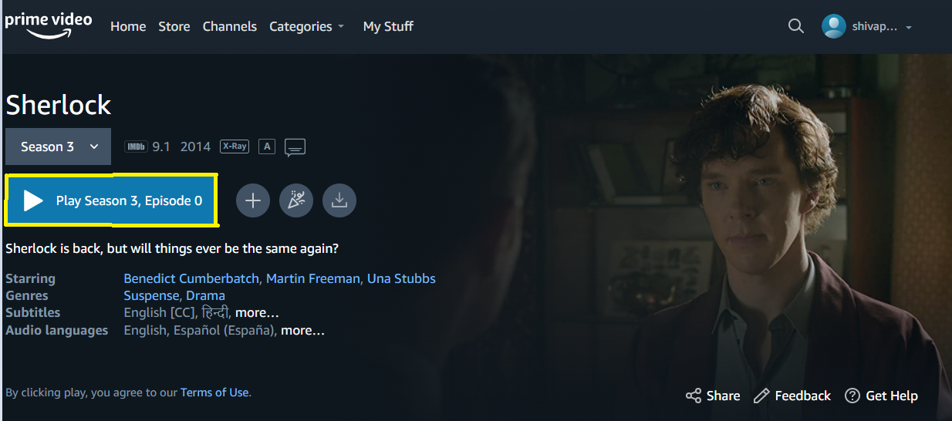

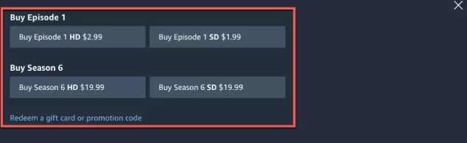

Or you could purchase a movie like Madirasi on Manorama Max

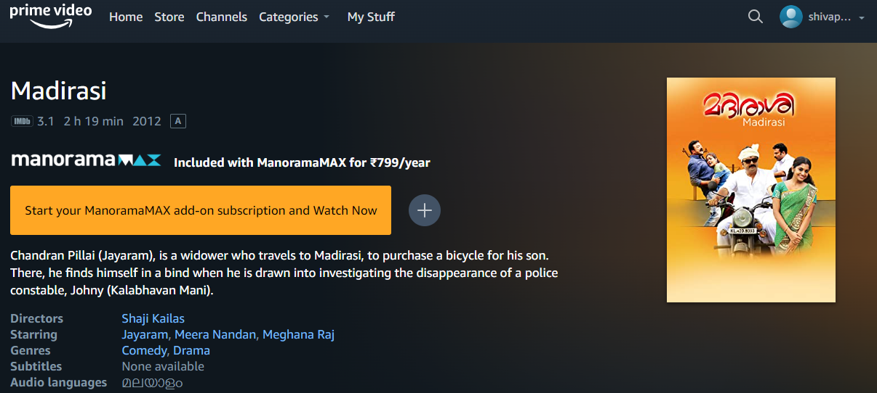

|  |
| --- |
| Note: You can earn a more consistent income with TVOD than with AVOD but you'll need to market your products consistently to generate steady purchases. |

## SVOD

The term **SVOD** stands for **Subscription Video-on-Demand.** With subscription video on demand (SVOD), you sell access to your videos online for a recurring monthly or annual fee.

As with Netflix, Amazon Prime Video, or Disney+, you pay a monthly subscription to watch your choice of videos.

A subscription video-on-demand platform (SVOD) will account for 55-60% of OTT revenue in India by 2030, overtaking advertising-driven platforms that will account for 40-45%.

By 2030, one India SVOD household will pay for more than four platforms!

**SVOD Pros**

* Since it's an ad-free service, users tend to stay longer and consume more content. (Think Netflix binge-watching!)
* You can use it to build a community around your exclusive content.
* Recurring income is generated by SVOD.
* OTT revenue models can vary within SVOD. For example, you can charge a flat fee for all content (AKA paid all access), or you can have tiers of membership, where the more you pay, the more content you get.
* An existing community can be monetized this way.

**SVOD Cons**

* In order to improve your product, you'll need to consistently produce high-quality, original content.
* Changes in content or pricing or inflation can cause people to cut back on spending can lead to subscriber losses.

Example:

Netflix, Amazon Prime Video, Disney+, Apple TV+, HBO, Hulu, and YouTube Premium are some examples of SVOD.

Nevertheless, Netflix pioneered the subscription model. For a monthly or annual fee, you can access an extensive library of feature films, documentaries, TV shows, anime, and Netflix originals:

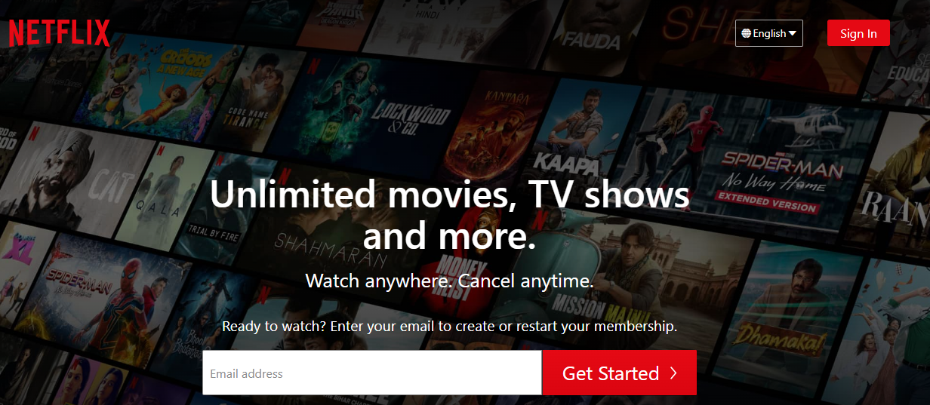

By monetizing your existing community, you can build a stable and consistent income over time using the SVOD model.

## Hybrid : SVOD+TVOD

The combining elements from both **SVOD** and **TVOD** monetization strategies, the hybrid model offers the best of both worlds.

You can cater to both long-term and short-term customers with recurring subscriptions and one-time purchases.

Example

The Disney+ subscription costs ₹899 per month, but subscribers must pay an extra ₹2400 per month to watch much-anticipated movies like Mulan before everyone else.

Disney’ s hybrid VOD model combines SVOD with Premium Video-On-Demand (PVOD), a type of TVOD.

# PROS and CONS in any OTT application you use as an end customer

**PROS of OTT platform**

Once the subscription is paid for, anyone can access the top-quality content. OTT Platforms flourished more during the pandemic, playing a very important role in the development of information technology.

OTT platforms like Netflix, HBO, KODI TV, IPTV, etc., are becoming increasingly popular to a great extent. To get more on-demand entertainment, people subscribe to streaming channels even more. Here are some reasons why people are using streaming services online.

## 1.Reduced Cost

The ability to watch international web series, shows, live sports telecasts, and favorite flicks on the go is one of the greatest pros of streaming platforms. You can access thousands of programs with a monthly subscription. There are also no monthly bills or interruptions for cable operators. Online digital content can be watched cost-effectively if one registers and pays a monthly or yearly subscription.

## 2. Crisp Sound and Picture Quality

As the OTT platform is offered online, the higher your speed, the better the auditory and visual content quality.

With an OTT platform like HBO and Netflix, you can customize the video and audio quality to your liking, which is a great advantage.

## 3.Instant Playback

The OTT platform also provides instant access to any movie or show at any time, irrespective of their release date. You can watch your favorite web series as often as you like.

The hassle of long ticket lines in theatres or annoying television advertisements during movies is gone. You can watch movies instantly and without any limitations, even when you're on the road. Some platforms charge a flat monthly fee in exchange for full access to their programming.

## 4.No language barrier

Depending on your geographic location, most content is available in regional languages. If not, subtitles are available, and an average viewer is exposed to world cinema.

## 5.Multi-Platform Service

You can binge-watch your favorite content on your smartphone if you need more time to log on to your desktop or laptop.

Mobile phones, laptops, smart TVs, and other audio-visual devices with an internet connection can easily access these media services, including video-on-demand and digital content at an international level.

## 6.Original Content

By subscribing to HBO, you get access to a wide variety of original content that can be accessed only with authorization. You manage the stuff independently as the account owner without external intervention.

**Cons of OTT platform**

The main advantages of OTT platforms are the price factor and the variety of content they offer. However, there are a few disadvantages that also make them stand out as being disadvantageous.

## 1.Online Limitation

Internet connection, you can enjoy streaming platforms. The downside to streaming media from a website is that the material is only available online. This option limits accessibility to the material for those without an online presence. To watch your favorite show, you must also have an account on a streaming platform.

## 2.Poor Network can Impact your viewing

An unstable connection is another disadvantage of streaming online. Because the content is HD quality, a slow connection will make it difficult for you to watch the media without interruption. Streaming media requires a stable internet connection to work. To experience HD quality, your internet connection needs to be at least 2MBPS. Otherwise, you will experience buffering.

## 3.Online Security

There are thousands of untrusted OTT platforms outside HBO, Netflix, and other popular ones. You may lose your confidential information while paying for a subscription through such platforms.

Cybercrime can also occur on platforms that ask you for personal information, including your bank details. Although many reputable platforms have tightened their security, many still require tweaks.

## 5.No Censorship

There are no age restrictions for viewing content on OTT platforms. They operate independently and do not follow governmental policies. OTT Platforms only aims to bring content that reaches a broader audience. One of the disadvantages is that the content could be more varied. Underage users may be adversely affected by such content.

## 6.Users waste too much on OTT Platforms

Because OTT Platforms have a lot of web series, movies, and shows released every week, users are more likely to waste their time watching them. As a web series ends, another one appears in the recommended segments. People who watch live video streaming are more likely to become addicted to online content than to be socially active in real life.